**PROJECT REPORT**

**Project Name** :- Smart Agriculture System Based On IOT

**1.**  **INTRODUCTION :**

* 1. **Overview**

The Objective of this report is to proposed IOT based Smart Farming System which will enable farmers to have live data of soil moisture,temperature and humidty .

* 1. **Purpose**

To develop application by which farmer can monitor weather details from their farm.IOT based farming is highly efficient when compared with conventail approach.

1. **LITERTAURE SURVEY :**
   1. **Existing Problem**

Use IOT platform to simulate data such as temperature,humidity and soil moisture.

* 1. **Proposed Solution**

Farmer can monitor temperature,soil moisture and humidity by using iot.

1. **THEORITICAL ANALYSIS :**
   1. **Block Diagram**

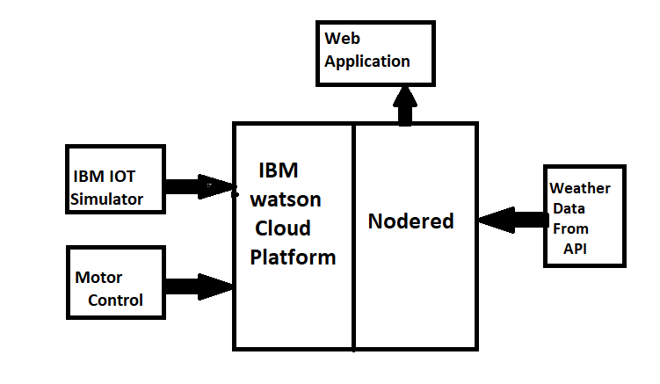

* 1. **Software Designing**

- Python code to subscribe IBM IOT platform

**4 . EXPERIMENATAL INVESTIGATIONS :**

We used ibm iot simulator to who sence data to cloud platform and data from open weather api is send to node red as well. We create buttons to give commands for motor.

1. **FLOWCHART :**

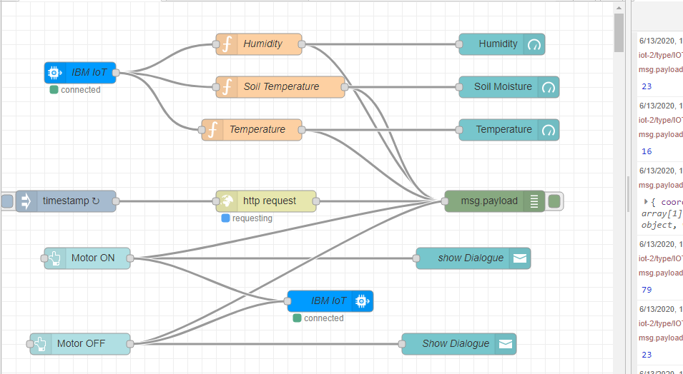

1. **RESULT :**

We accessed data from open weather api to get weather details such as temperature moisture from the farm.

1. **ADVANTAGES & DISADVANTAGES :**

Advantages :

- Data Collection

- Reduction Of risks

Disadvantages :

-Privacy issue

1. **APPLICATION :**

Farmer can get realtime weather data by using IBM IOT platform

1. **CONCLUSION :**

By using IOT platform we can monitor temperature,soil moisture,humidity in farm

1. **FUTURE SCOPE :**

Farmer can use this to get weather data from their crop

1. **BIBILOGRAPHY :**

Appendix :

1. Source Code

* http ://en.m.wikipedia.org/wiki/internet_of_things
* https://youtu.be/MYp_aERiyew